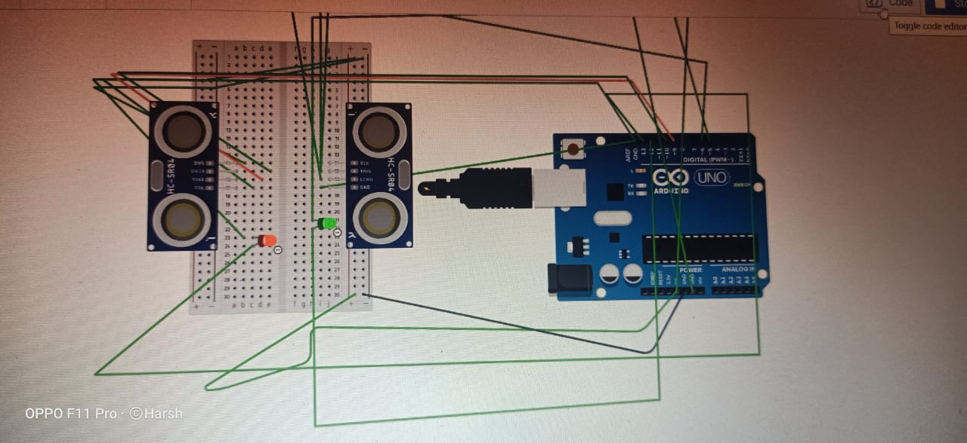

Theory:
Concept used:As the task says the red light should start blinking when someone walks from front of the car and green light should blink when someone walks along its back .
Learning and observation: learned about connecting circuits and the mechanism used in this task.
Problems and troubleshooting: the problem encountered was int the idea genetration but then the concept used in various devices with sensors gave a hint.

